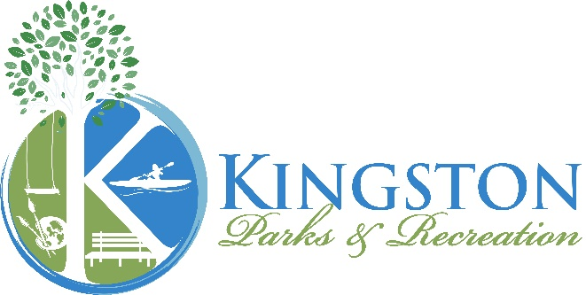
Kingston Parks & Recreation Mission:
"Building and enriching our community by working together"

Gray's Beach Park Policies & Procedures
Parking Stickers Required - Stickers on Sale April 1st
Amenities
Grass Area • Playground • Tennis Court • Basketball Court • Restrooms (seasonal) • Pavilions with Picnic Tables • Stage • Boardwalk & Benches
Park Hours
Dawn to Dusk • Restrooms: 8 AM - 7 PM (seasonal, weather permitting)
Parking Stickers (Required for Entry)
- Resident Sticker (Gray’s Beach Park & Ah-De-Nah) – $30 (pickup) / $35 (mailed)
- Non-Resident Sticker (Gray’s Beach Park ONLY) – $60 (pickup) / $65 (mailed)
- Senior (62+) / Veteran Discount: $5 Off (*Note: The Senior discount will be applied during checkout, for the Veteran discount please use the applicable Veteran Registration)
- Transfer Station Parking Permit – via Highway Dept.
Park Rules
✅ Parking Sticker Required
✅ Smoke-Free Property
✅ Leashed Dogs Allowed (Grass & Walkways Only)
✅Carry-In, Carry-Out Trash Policy - Please remove all trash to keep our park clean!
❌ No Dogs on Beach, Basketball Court, or fenced Playground/Tennis Court
Owners must clean up after pets. Violations subject to fines (Town By-Laws Ch. 10 & 15).
Liability & Compliance
- Park provided under M.G.L. Chapter 21, Section 17C (Recreational Use Law).
- The Town of Kingston is not responsible for personal injuries or personal property damage.
- All State & Local Guidelines/Directives must be followed.

