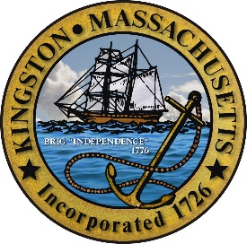

*Town of Kingston*

244 Main Street, Kingston, Massachusetts, 02364 Business: (781) 585-0523; Fax: (781) 585-7556

**Citizens Police Academy**

**Application**

**Brian J. Holmes**

**Chief of Police**

**Citizen's Police Academy Application**

**Personal Information:**

**Full Name: ____________________________________________________________**

**Date of Birth: ____________________________________________________________**

**City: ____________________________________________________________**

**State: ____________________________________________________________**

**Zip Code: ____________________________________________________________**

**Phone Number: ____________________________________________________________**

**Email Address: ____________________________________________________________**

**Employment Information:**

**Current Employer: ____________________________________________________________**

**Job Title: ____________________________________________________________**

**Employment Dates: ____________________________________________________________**

**Address: ____________________________________________________________**

**City: ____________________________________________________________**

**State: ____________________________________________________________**

**Zip Code: ____________________________________________________________**

**Background & Interest:**

**Do you have any civic or group affiliations?  
_____________________________________________________________________________**

**If 'Yes,' please list them:  
______________________________________________________________________________**

**Have you ever had any involvement with the Kingston Police Department or any other police department?  
______________________________________________________________________________**

**If 'Yes,' please explain:  
______________________________________________________________________________**

**Please explain why you are interested in attending the Citizen's Police Academy and what you hope to gain from it.  
______________________________________________________________________________**

**Please provide any additional information that you think would make you a good candidate for this program.  
______________________________________________________________________________**

**The Citizen's Police Academy meets every Monday & Thursday from 6:00 PM - 8:30 PM. Would you be able to commit to attending these sessions?  
_______________________________________________________________________________**

**If you answered 'No,' please explain:  
______________________________________________________________________________**

**Notice:**

**The Kingston Police Department will conduct a background check of each applicant. By signing below, you are aware of the background check and consent to it. The background investigation may include, but is not limited to:**

* **Criminal Offender Record Information (CORI)**
* **License status and history**
* **Criminal and Civil Warrants**

**Signature: ________________________________________  
Date: ________________________________________**