K-Rec Konnect - Family Information Sheet

Please review these policies and if you have any questions please do not hesitate to contact us at the Recreation Department Office: (781) 585-0533.
Policies subject to change if state guidelines and protocols change.

- A touch free water system has been installed in the building for each child to refill their water bottle when necessary.
- Masks are no longer required, but they are recommended for individuals inside if they are not vaccinated, but it is not being REQUIRED for anyone to wear them.
- If families want their children to wear masks, families must provide them, and we will try to have them keep them on when social distancing is not possible.
- Children MUST bring their own water bottle, if they do not have it with them they will be asked to go with their families to go get their water bottle and return, as we will not be providing cups, in order to assist with sanitization situations, and it is imperative that all children have a water bottle.

Drop Off:
- For the safety of your child:
- Counselors will not be ready to watch children prior to the scheduled drop off time as they have meetings discussing that day’s activities. DO NOT drop off children unattended.
- Parents/Guardians will be required to walk down with their children to the designated check in area for their groups and sign in with their counselors. This includes all ages (including your 7th & 8th graders). Do not drop off children, or let them walk down alone and leave them unattended.
Pick –Up:
  - Parents/Guardians will be required to walk down and sign out their children with their counselor at their designated area.
Daily Information:
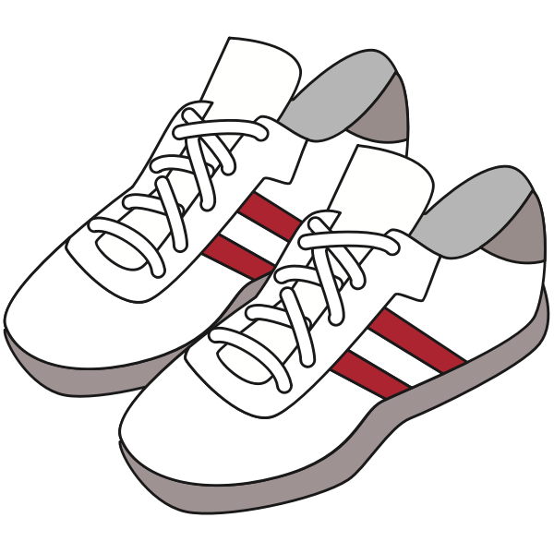
- Children must bring a water bottle daily.
- Children must wear sneakers for activities.
- Children should not bring any food, unless needed for medical reasons.
- NO cell phones or electronic devices allowed, this causes too much controversy amongst participants, as well as the possibility for items to be lost or broken during activities.

-Parents/Guardians will be notified through email and blast prior to any program changes.

Heat Advisory Policy:
- In the event of a Heat Advisory, programs for that day will be cancelled for the day.
Rainy Day Policy:
- In the event of a rainy day, we will have limited inside activities, due to space constraints and social distancing for inside activities.
Do not send your child to the program if:
1. They or anyone in your family have a fever.
2. They or anyone in your family have flu like symptoms; a cough, sore throat, sneezing, wheezing, shortness of breath or trouble breathing
3. They or anyone in your family has been in contact with a suspected or confirmed COVID patient

Wild & Free

As a reminder this is the Disclaimer You Electronically Signed when you registered your child - Please Read Carefully
Release:
Coronavirus, COVID-19 is an extremely contagious virus that spreads easily through person-to-person contact. Federal and state authorities recommend social distancing as a means to prevent the spread of the virus if unvaccinated. COVID-19 can lead to severe illness, personal injury, permanent disability, and death. Participating in programs or accessing facilities could increase the risk of contracting COVID-19. The Town of Kingston in no way warrants that COVID-19 infection will not occur through participation in programs or accessing Town facilities.
I understand there are risks of physical injury in participating in sports and recreational activities or programs.

Participants should notify the Recreation Department of prior respiratory issues, medical conditions, allergies, and other specific allergy issues. Participants should not attend if they or someone in their household are at high risk for severe illness

I hereby release the town of Kingston, its employees, officials, and agents from any and all liability or loss or damage to personal property that my child or I may experience in connection with activities sponsored by the Kingston Recreation Department.

I hereby consent to emergency medical procedures deemed advisable for my child in the event I cannot be reached, and my child has sustained an injury. The Dept. does not provide accident or hospitalization insurance for participants of its programs. All participants are advised to have adequate personal coverage. Please consider the participant's own health, experience, and tolerance for risk before participating in any program. I also consent to the use of my or my child’s photo, video, artwork etc. by the department for flyers, presentations etc.

We can’t wait to see you for summer fun!
Susan Woodworth, Director of Parks and Recreation
Debbie Doherty, Recreation Office Program Administrator
Katie Hall & Kirstyn Tanous, Summer Program Directors

Children/Families Checklist

___________________ Daily Checklist
(child’s name)

- Water Bottle
- Sneakers
- Positive Attitude

